DAY 3 – MANUAL TEST CASE MANAGEMENT
Test Creation: Create Test issue, test description, Preconditions usage
Test Design: Step-based tests, unstructured tests, real-project selection
Test Organization: Test Sets, smoke tests, regression grouping, feature-wise grouping
Linking Strategy: Link Tests to Stories, Tasks, Bugs, traceability visualization

Test Creation: Create Test issue, test description, Preconditions usage ::
Creating a Test Issue in Xray :
In Xray, each manual test case is represented by a Test issue. Creating a Test issue involves defining clear objectives, steps, and expected outcomes.
Key Components of a Test Issue:
- Summary: Brief description of what the test validates
- Description: High-level purpose of the test
- Test Type: Manual
- Test Steps: Step-by-step actions and expected results
- Linked Issues: User stories, tasks, or bugs
A well-written Test issue ensures clarity and repeatability, allowing any tester to execute it consistently.

Test Description :
The Test Description explains: What this test is about and why it exists. It is NOT the steps. It is the scenario explanation. A good description is Ex : Verify that a registered user can successfully log in using valid credentials and is redirected to the dashboard. Use Given / When / Then even for manual tests. This improves: Clarity, Reusability, Automation readiness
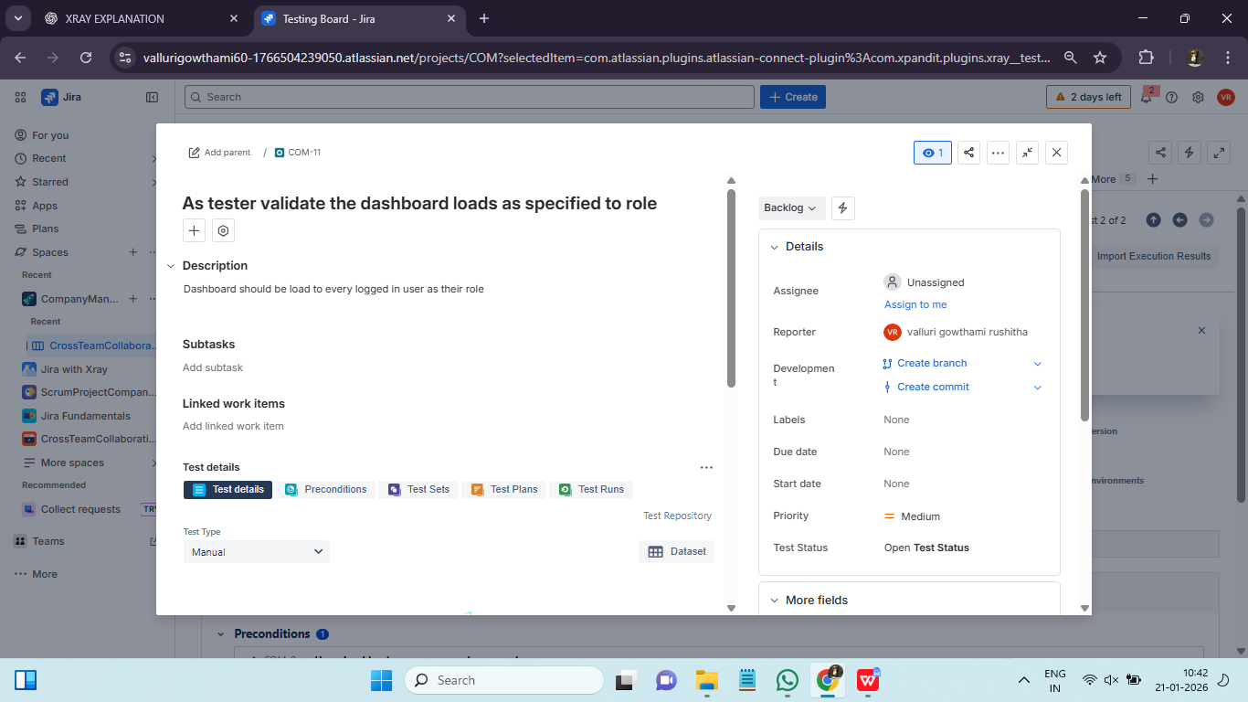
Preconditions Usage:
Preconditions define the required setup before executing a test case. Examples include user login, data availability, or system configuration.
Benefits of Preconditions:
- Avoids duplication of setup steps
- Promotes reuse across multiple tests
- Improves test readability
In Xray, Preconditions are separate issue types that can be linked to multiple Test issues. This approach improves maintainability and consistency.

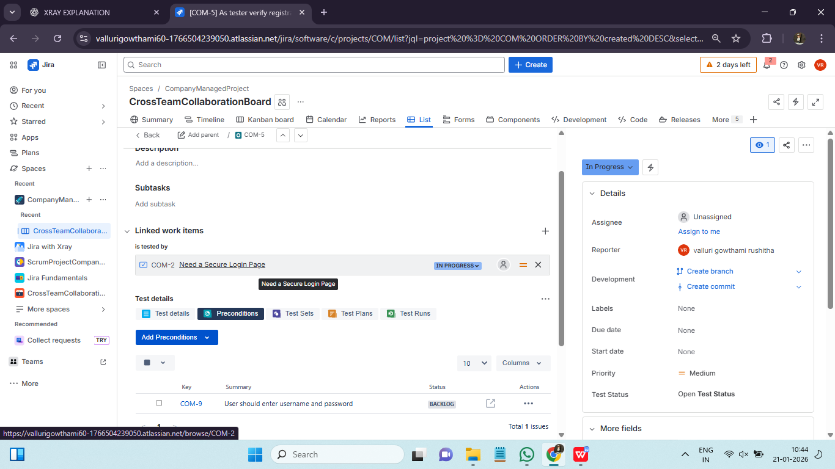

Test Design: Step-based tests, unstructured tests, real-project selection ::
Xray supports multiple test design styles to suit different project needs.
Step-Based Tests:
- Clearly defined steps and expected results
- Suitable for functional and regression testing
- Easy to execute and review
Unstructured Tests:
- Free-text description
- Suitable for exploratory testing
- Flexible but less formal
Selecting the appropriate test design depends on project complexity, risk, and team maturity.

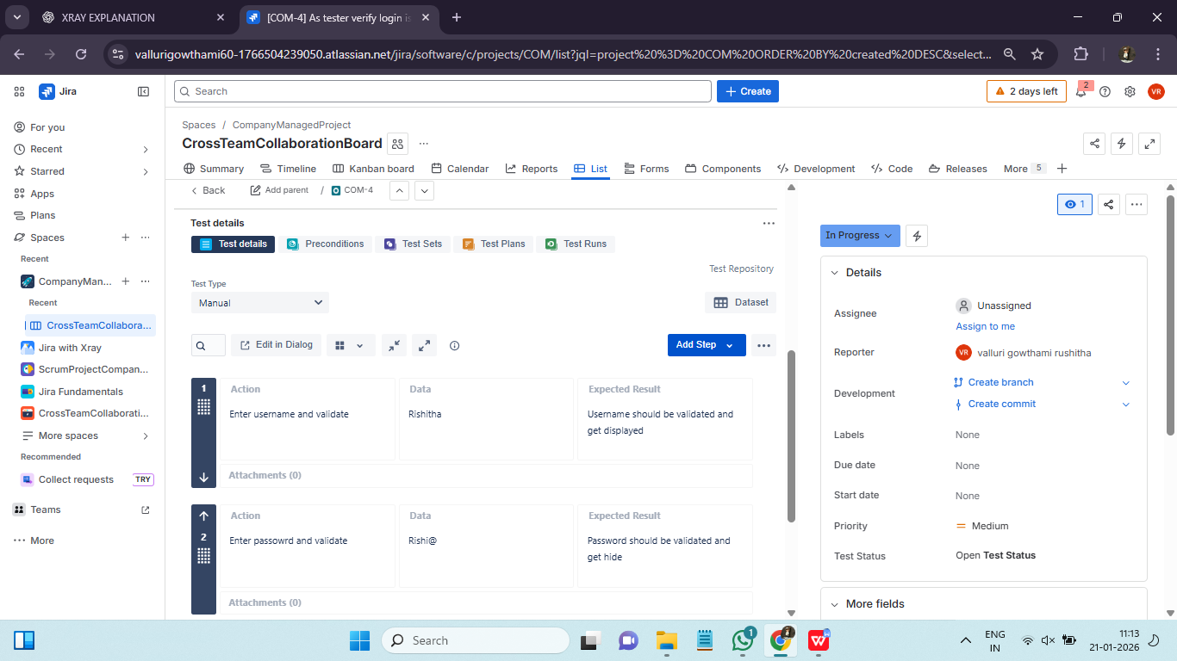
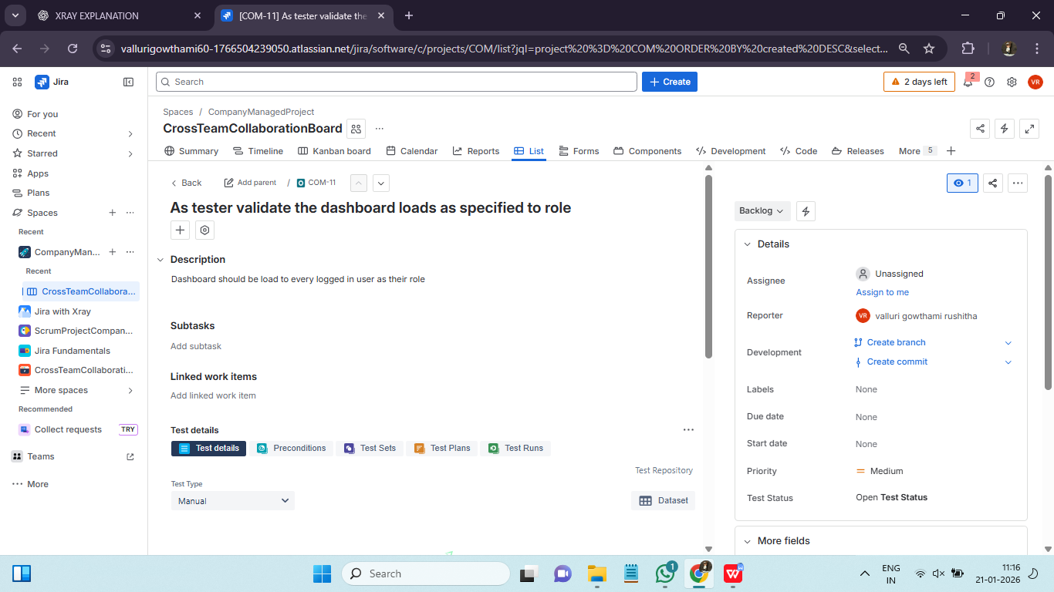
Real project selection :
In real projects we don’t use only one style, we choose based on risk, stability and audience.
Step based tests : Clarity & audit , regression tests, stable and repetable scenarios.
Unstructured tests : Speed & exploration, flexibility.
Most mature teams follow:
80% step-based tests
20% unstructured / exploratory

Test Organization: Test Sets, smoke tests, regression grouping, feature-wise grouping ::
As projects grow, managing hundreds or thousands of test cases becomes challenging. Xray provides Test Sets to group related tests logically.
Common Test Set Types:
- Smoke Test Set
- Regression Test Set
- Feature-Specific Test Set

Smoke Tests:
A small set of critical tests that verify the system is stable enough for further testing. Smoke tests answer: Is the build testable?
- Validate basic system functionality
- Executed after builds or deployments
- Executed daily
- Executed after every build
- Must be fast

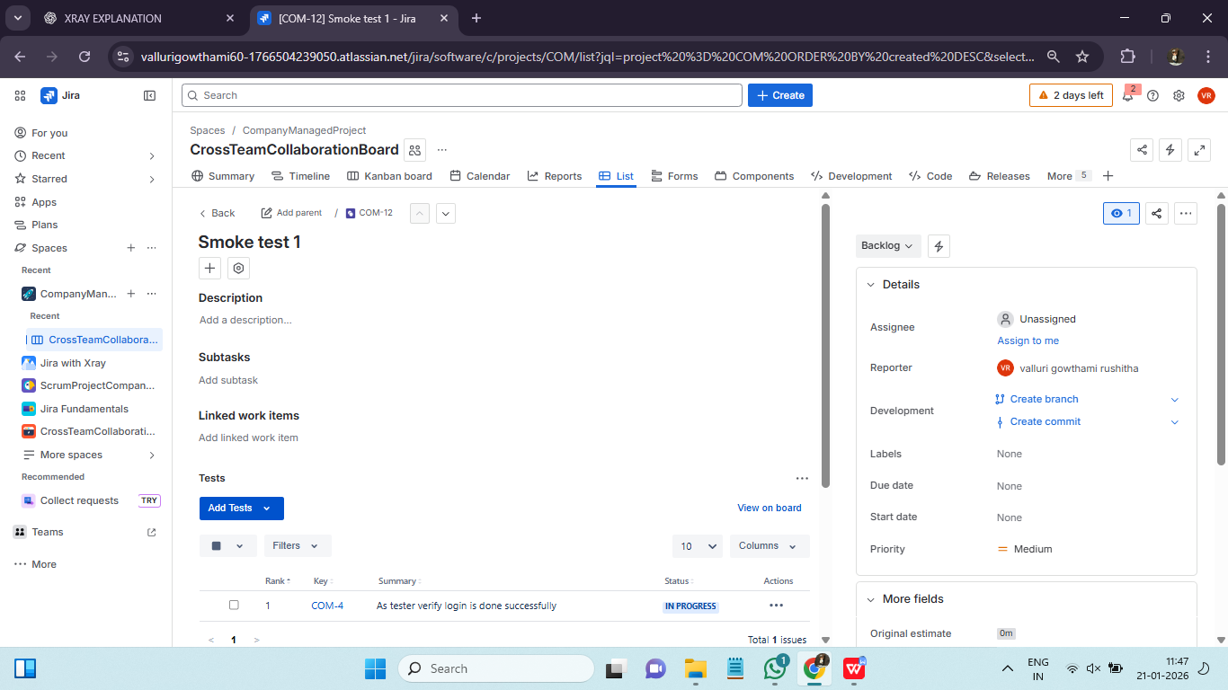

Regression Tests:
Regression Testing ensures: Existing functionality still works after new changes
Regression tests are:
- Large in number
- Executed frequently
- High maintenance
- Ensure existing functionality remains unaffected
- Executed before major releases

Using Test Sets for smoke and regression testing ensures consistency and faster execution cycles.

Feature-Wise Grouping
Feature-wise grouping means: Organizing tests based on application features or modules Each feature has: One or more Test Sets. It is important because :
- Easy ownership
- Clear responsibility
- Scalable structure
Feature-wise grouping mirrors:
- Product architecture
- Team structure
This structure helps teams assess feature readiness during sprint reviews.

Linking Strategy: Link Tests to Stories, Tasks, Bugs, traceability visualization ::
In Xray, linking strategy defines: How test cases, requirements, executions, and defects are connected to give real-time visibility of quality. Linking = quality intelligence graph. In Xray, linking defines traceability, not just relationships.
Link Tests to Stories :
It means: This test validates this requirement
Story = What to build : Test = How to verify
It Enables requirement coverage, Shows test completeness, Enables impact analysis. Linking enables full traceability from requirements to defects and supports audit readiness.
Link Tests to Tasks :
Tasks represent: Technical work, UI changes, Backend changes. Sometimes: No formal Story exists, Task still needs validation. Use Tasks when:
- Small enhancement
- Technical refactor
- Support work
- Avoid tasks for business requirements
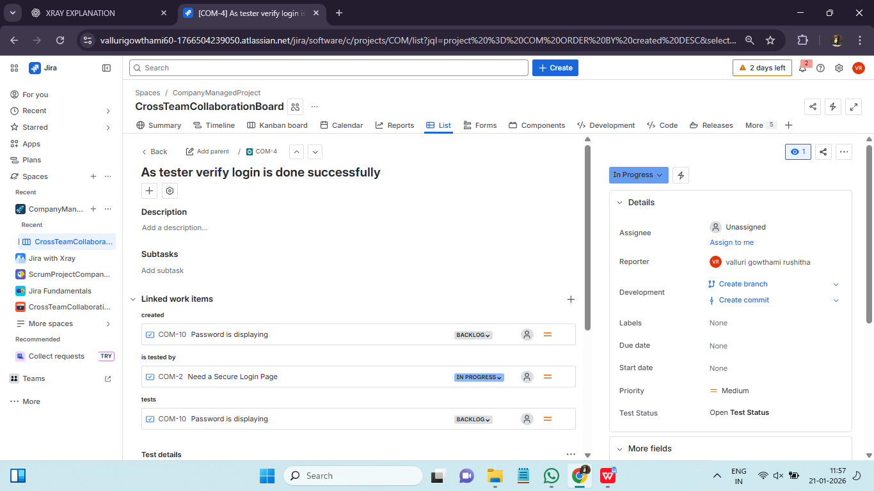
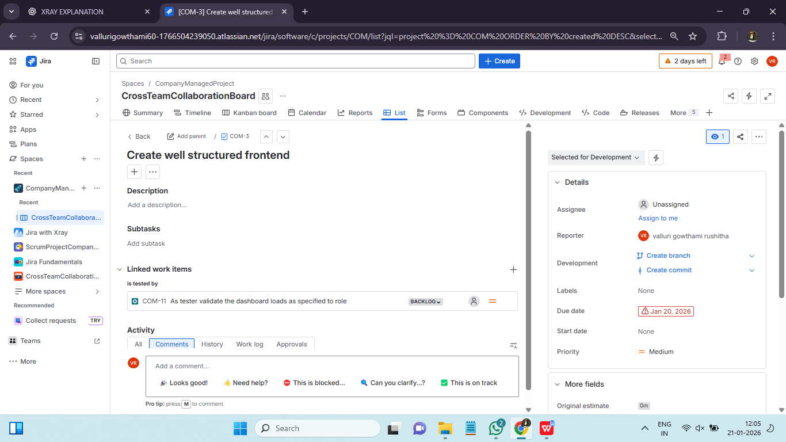
Link Tests to Bugs:
Bug linking answers: Which test exposed this defect?
Types of bug linkings :
Link Type | Meaning
Found during | Bug found while executing test
Relates to | General relation
Is caused by | Root cause link
With correct linking, you can answer:
- Which tests are failing because of this bug?
- Which requirements are blocked?
- Has the bug been retested?
This is defect impact analysis.

Traceability Visualization

Xray provides visual traceability through coverage views and reports. These views help teams:
- Identify untested requirements
- Track failed test impact
- Monitor testing progress
Traceability visualization shows: The entire quality chain in one view
Location | What You See
Story | Coverage panel
Test | Linked requirements & executions
Test Plan | Coverage summary
Reports | Traceability matrix

Xray traceability provides :
- Evidence
- History
- Accountability

